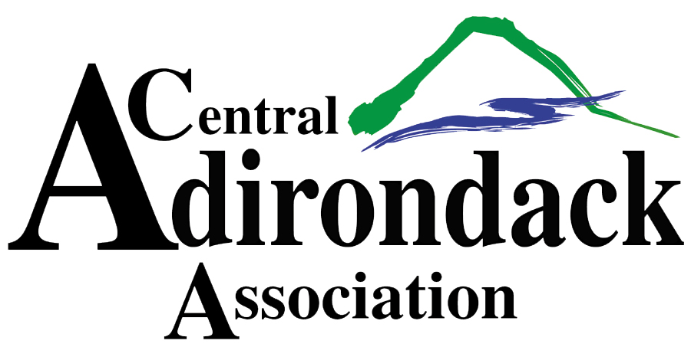

**SNODEO VENDOR APPLICATION**

**DECEMBER 13th & 14th – NEW 2 DAY SHOW!**

**To request booth space, please fill out the form below and return no later than November 15th**

**NEW THIS YEAR – FRIDAY “KICK-OFF TO WINTER PARTY” 4 -9pm! LIVE MUSIC & FIREWORKS!**

**SATURDAY – 9am – 6pm. YOUTH RACES AT NOON, RAFFLE DRAWING AT 5pm!**

1. Booth set up times will be Thursday, 12/12, from 9am-5pm and Friday, 12/13, from 9am-1pm. All vendors must be set up and ready for operation by opening of show.
2. Hours of operation; Friday, 12/13, from 4-9pm (NEW TIMES), Saturday, 12/14, 9am-6pm.
3. The pavilion will close at approximately 6pm on Saturday. Breakdown will begin at this time. All merchandise must be removed no later than Noon on Sunday, 12/15.
4. No running machines in the pavilion.
5. No set up allowed until booth space paid in full.
6. One 8 ft table and 2 chairs per vendor space. Electricity and WIFI available.
7. All vendors must provide a certificate of insurance listing the Town of Webb and the Central Adirondack Association additional insured. Please return certificates with application.
8. Payments must be received in full prior to November 15th. Make checks payable to the Central Adirondack Association.
9. Each vendor is asked to donate a door prize ($25 value) which will be collected and distributed during the event.
10. NO REFUNDS. NO RAFFLE TICKETS TO BE SOLD DURING EVENT.

**If you have any questions please contact Laurie Barkauskas at** [**laurieb@caany.com**](mailto:laurieb@caany.com) **or 315-369-6983.**

**BOOTH SPACE REQUEST FOR SNODEO 2024**

BUSINESS NAME;_____________________________________ PHONE:_______________________

ADDRESS:__________________________________________________________________________

CONTACT NAME:___________________________ EMAIL:___________________________________

PRODUCTS SOLD:_____________________________________________________________________

10 X 10 INTERIOR BOOTH SPACE - $250 _______ 10 X 20 INTERIOR BOOTH SPACE - $400 _______

EXTERIOR 10 x 10 SPACE- $150 ________

SIGNATURE:___________________________ DATE:_______________________________

CENTRAL ADIRONDACK ASSOCATION, PO BOX 68, OLD FORGE, NY 13420