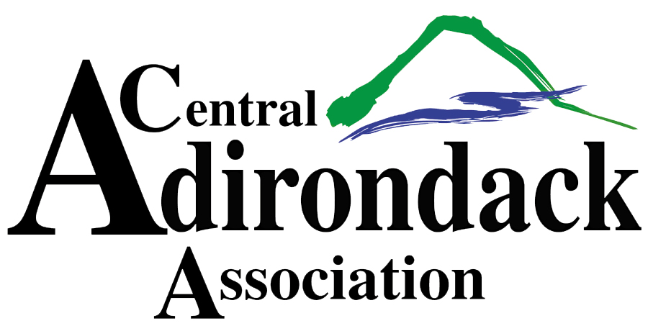

**OCTOBERFEST VENDOR APPLICATION**

October 14th, 2023 – 11am – 5pm

George T. Hiltebrant Recreation Center, North St., Old Forge NY

To request a 10’x10’ booth space please fill out the form below and return no later than 10/01/23 by mailing to the address below or emailing to [laurieb@caany.com](mailto:laurieb@caany.com).

**VENDOR NAME: __________________________________ __________________**

**EMAIL: ________________________________ PHONE:_____________________**

**ADDRESS:___________________________________________________________**

**PLEASE DESCRIBE THE CRAFTS/PRODUCTS YOU WILL BE PROVIDING BELOW:**

**ELECTRICTY NEEDED: ______ YES _______ NO**

**SPECIAL NEEDS/REQUESTS:_________________________________________________**

**CRAFT VENDOR ($25) ________ FOOD/BEVERAGE OR RETAIL VENDOR ($75) _________**

**TAX ID#:_______________________ SIGNATURE:_______________________________**

Please return this completed form with payment no later than 10/01/23! Please make checks out to CAA. Include certificates of insurance naming the CAA, PO Box 68, Old Forge, NY 13420 and the Town of Webb, PO Box 157, Old Forge, NY 13420. Feel free to contact Laurie at [laurieb@caany.com](mailto:laurieb@caany.com) or 315-369-6983 (x-23) with any questions. Hope to see you there!